Install screen firmware

1. Format SD CARD
Start=》CMD（Win 7）=》format/q g:/fs:fat32/a:4096 =>Enter
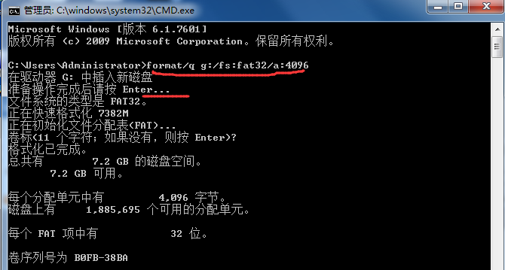

"g" is the disk number of your SD card that shows at computer, right click your mouse to format is usually invalid; generally the capacity of he SD card is about 2-16 G

- After formatting,save“DWIN_SET”files to SD card,insert SD to the card slot at touch screen,turn on,it would be upgrade.
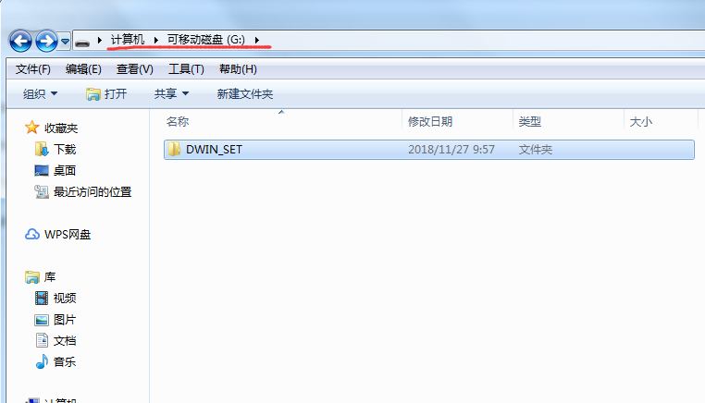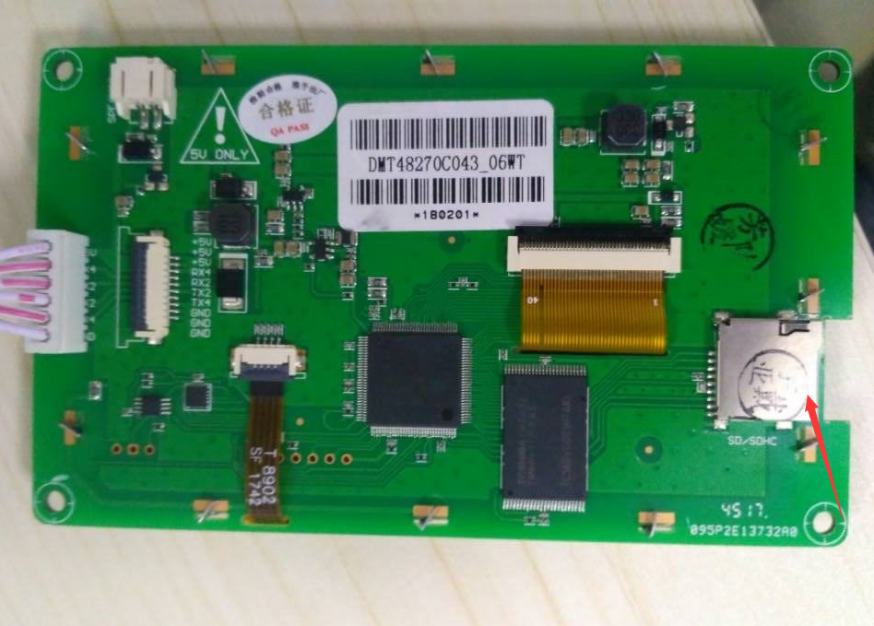

Note：If there are problems after upgrading,please try it again.

